Handwriting and Printed Bengali Script Word Segmentation Using Structural Analysis

Pritilata Biswas^{1*}, Arifa Islam Champa¹, Sumaia Afrin Prity¹, Parvez Abedin Siddique¹

- Department of Computer Science and Engineering, Bangladesh Army International University of Science and Technology, Cumilla, Bangladesh

- email: pritilata.biswas66@gmail.com tel.: +8801923388240

Abstract

Bangla character recognition is becoming a momentous issue in several years but it becomes a challenge to get good performance due to the segmentation and many of them are similar. This problem is not solved yet for several ambiguous scripts. Also, many best OCR engines cannot solve this problem. In this paper, the main objective is to focus on the segmentation process of OCR system. The input image is processed by using various filters like grayscale filter, bilateral filter, skew angle correction and binarization. Then for segmentation purposes, the lines of the scripts are segmented using the HPP and VPP structural analysis process. Here the work is mainly to detect the words correctly that solve the problem of word segmentation for Bengali script.
Keywords- Bengali character, HPP, Image binarization, Segmentation, VPP.

Introduction

Segmentation of Bangla handwritten text is the pre-process of handwritten text. The Bengali script is also used for representing other languages like Meithei and Bishnupriya Manipuri, and there is a time when it used to write Sanskrit within Bengali. Most of the Bengali characters are topologically connected. They can be easily classified using this connectedness [1]. This classifying or segmentation of the Bengali character is the most challenging task in making a Bengali Script OCR. In Bengali, there is a combination of simple and compound characters. The combination of characters can be more than 300. Here, Bengali character segmentation is the most challenging task. So, it needs some robust techniques that can classify these compound characters.
Table 1: Some compound characters in the Bengali script [2].
Connected Character | Base of the Character
ক্ট | ক+ট
ন্ড | ন+ড
ষ্ট্র | ষ+ট+র

As Bengali script characters are connected with a Matra line, so the characters can be easily recognized by the connected component analysis [2]. In this paper, main objective is to improvise the method of analyzing the line and word of the Bengali script using HPP and VPP respectively.

Related works
The segmentation of the Bengali script is analyzed by various authors who proposed various methods. These are described below:

Zahan et al [2] proposed a process of segmentation for Bengali script. They detected the matra line correctly. Then from this detected line, they separated the characters into two separate zones. Their method mentioned a zone-based solution of the problems of segmentation in Bengali script.

Obaida et al [3] described an algorithm that uses the horizontal projection approach to solve the problem of skewness of some language scripts. They described an easy and feasible method called OJ technique that solve the skewness of any form of rotation.

Methodology
Firstly, the input image will be turned into a grayscale image by applying grayscale filter and bilateral filter. Then using bit plane slicing the input image will be binarized. For skew angle correction, the skew angle technique is applied [3]. There is a small gap between the two lines called the horizontal gap. Those gapes by horizontal projection profile (HPP) and Vertical projection profile (VPP) will be used in word segmentation from detected lines by detecting the vertical gaps of a word.

Steps 3: Word segmentation

1. Apply VPP
Step 2: line segmentation

1. Apply HPP
Step 1: Input Processing

- Apply grayscale filter
- Apply bilateral filter
- Image binarization
- Skew angle correction
Input image

Figure 1: The proposed methodology.

A detailed overview of the whole process is given below:

  - Pre-Processing

In this step, a general image is taken as input between 100-300 dpi. At first, the input image is turned into a grayscale image by applying the grayscale filter. This filter changes the color scheme into grey shade. Then the bilateral filter is applied on that image. This filter makes the edges of the image sharper so that they can be easily detected and this is also used for noise removal of an image. After that, through binarization, the image is converted to a black and white image. The skew angle of the image can easily determine by the skew matrix of an image. So, by multiply the skew matrix with the skew angle and applying that matrix on the input image the skewness can be easily removed.
  - Line Segmentation

Line of any language can be detected by the gap between two lines. A simple method called HPP in extend Horizontal Projection Profile. This method sums the number of black pixels in a row. The rows with the most numbers of pixels are the matra line and rows with lowest and no pixels is the horizontal gap between the lines. By this it can easily detect the lines.

  - Word Segmentation

Word segmentation can also be done as the same process like the line segmentation by the method called VPP extends Vertical Projection Profile. By which the black pixels of a column are summed from the detected line. The columns with the lowest numbers of pixel indicate the gap. By this simple method the vertical gap is detected.

Experimental Results
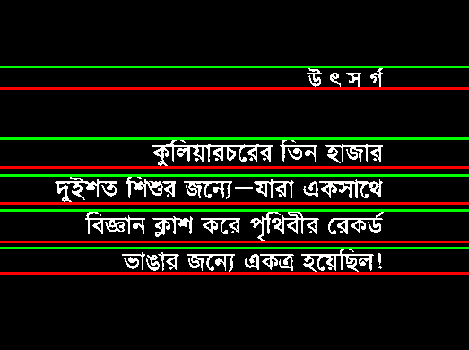
The output of applying HPP on the printed script is displayed in Figure 2(a) and handwritten script in Figure 2(b) .

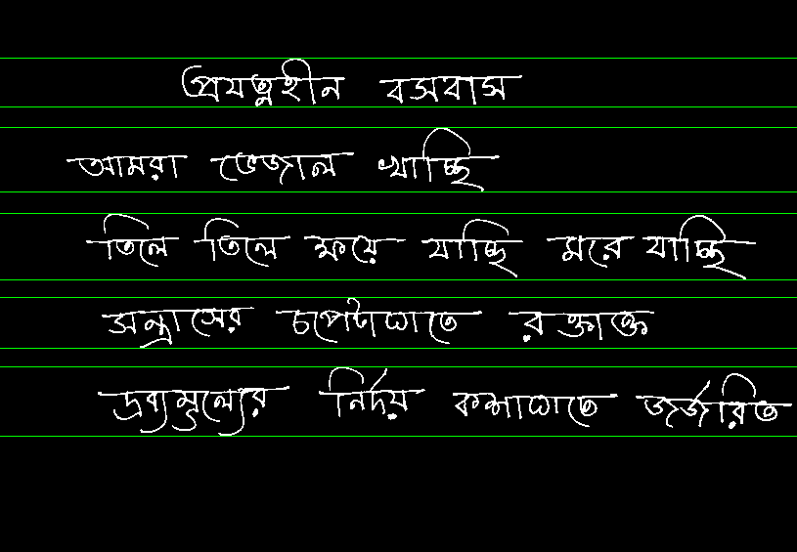
(a)
(b)
Figure 2: Line Segmentation of (a) Bengali printed script and (b) Bengali handwritten script.

Figure 3(a) depicts the result of applying VPP for Bengali printed script and 3(b) for handwritten script.
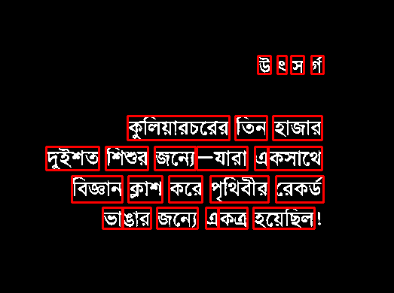

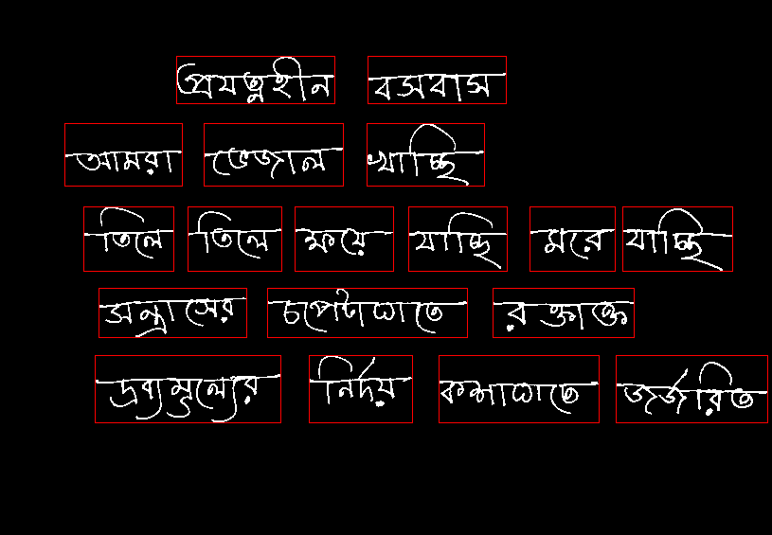
(a)
(b)
Figure 3: Word Segmentation of (a) Bengali printed script and (b) Bengali handwritten script.

Conclusion
In this paper, the main focus is on the segmentation procedure. For this segmentation, printed script is used as input. Then firstly the input image is preprocessed by four steps like grayscale filter, bilateral filter for smoothing the image, then we go for skew angle correction and finally by binarization the expected binary image is generated. Then that binary image is used for the segmentation process where the lines and then words of the image are segmented one after another.
In the future, character segmentation also be implemented. As Bengali characters are connected through the matra line and the total accuracy of the segmentation is mostly depending on the correct detection of the matra line, so the future plan is to detect the matra line accurately.

References

- B. B. Chaudhuri and U. Pal, “A Complete Printed Bangla OCR System,” Pattern Recognition, Vol. 31, No. 5, pp. 531—549, 1998.
- T. Zahan, M.R. Selim, M.S. Rahman, M.Z. Iqbal, (2018). “Connected Component Analysis Based Two Zone Approach for Bangla Character Segmentation.” 1-4. 10.1109/ICBSLP.2018.8554684.
- M. A. Obaida, T. K. Roy, M. A. Horaira and M. J. Hossain, “Skew Correction Function of OCR: Stroke-Whitespace based Algorithmic Approach,” International Journal of Computer Applications 28(8):7-12, August 2011.

